**PPM-Before Login Changes:**

**In Excel:-Before that in excel file Country wise-Company wise-Normal/Huge Usage –actually takes two types, they are Normal/Huge Usage. So that it will take two rows every element.**

**In Normal wise two rows like Home/Office**

**In Huge Usage wise two rows like Home/Office.**

**After that**

**After that the changes are taken as Monthly Premium as column name and fields are**

* **High**
* **Highest**
* **Lowest**
* **Moderate**

**Instead of Normal/Huge Usage and fields are Normal/Huge.**

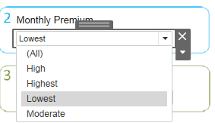

**We are changing the four rows instead of two rows like Purpose of buying Plan: Personal or Individual/ Corporate.**

**Country wise Revenue also changed.**

**Conversion Rate some of the fields are above 100% we are changed those percentages.**

**In Excel we are adding two columns Deductibles and Cost Based on Monthly Premium.**

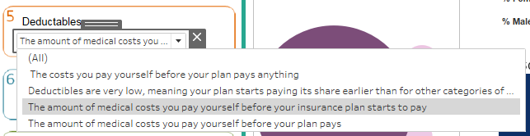

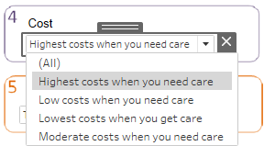

**In Workbook Level:**

**In workbook level we are change the shape image of Rectangles, add two Questions of Deductibles and Cost.**

**Here we can add another sheet as How many companies listed in our data.**



**These are change done till on 2019-09-12.**